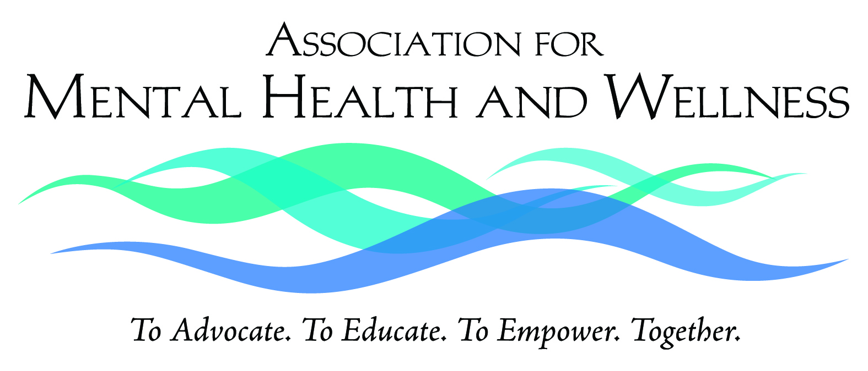

939 Johnson Avenue, Ronkonkoma, NY 11779 · (631) 471-7242 · www.mhaw.org

March 10, 2016 Contact: Ruth McDade
For Immediate Release Mobile: 631.672.9613
STATE GRANT TO AUGMENT SERVICES TO VETERANS IN BROOKHAVEN
Added focus on the unmet behavioral health needs of returning Veterans
RONKONKOMA, NY – The Association for Mental Health and Wellness (MHAW) will receive a $588,000 grant from the New York State Office of Temporary and Disability Assistance (OTDA) to fund a comprehensive range of supportive services for Veterans. The services include family and social supports that promote housing stability, employment, and self-sufficiency with a particular focus on behavioral health services.

Funded through OTDA’s NYS Supportive Housing Program, these services will be provided by Suffolk County United Veterans (SCUV), a program on MHAW. SCUV provides emergency housing for some 200 veterans annually as well as support services for more than 1,300 Veterans and their families each year.

“We are grateful to the state Office of Temporary and Disability Assistance for enabling us to continue and expand our services to Veterans,” said Michael Stoltz, LCSW, Chief Executive Officer of MHAW. “With Suffolk County being the home to the largest population of Veterans in New York State, our dedicated professional and peer staff at SCUV feel a special obligation to provide Veterans with the housing and other support services they need and deserve.”

The grant will target Veterans who reside in the Brookhaven Town hamlets of Yaphank, East Patchogue, North Bellport, Mastic Beach, Shirley, and Middle Island.

For more information, call (631) 924-8088.

The Association for Mental Health and Wellness (MHAW), a not-for-profit 501(c)(3) corporation based in Ronkonkoma, NY, provides programs, services, and advocacy for people facing mental health challenges with an enhanced focus on serving military Veterans.

Suffolk County United Veterans, a program of MHAW, offers a broad range of services delivered by trained Veterans and family members to assist at-risk Veterans and their families including outreach, crisis prevention and diversion, social and employment supports, and PTSD peer support.

###

