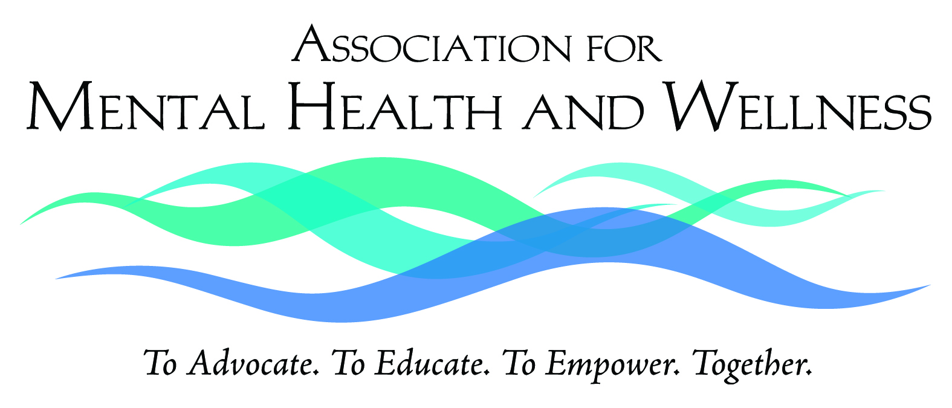

939 Johnson Avenue, Ronkonkoma, NY 11779 · (631) 471-7242 www.MentalHealthAndWellness.org
PRESS RELEASE
March 10, 2016
For Immediate Release
Contact: Ruth McDade
Telephone 631.672.9613
HOMELESS VETERANS ARE TO RECEIVE THE HELP THEY NEED

Added focus on the unmet behavioral health needs of returning veterans
RONKONKOMA, NY – The Association for Mental Health and Wellness, a not for profit behavioral healthcare organization headquartered in Ronkonkoma is proud to announce they have been awarded $588,000 in renewal grant funding from the New York State Office of Temporary and Disability Assistance through its NYS Supportive Housing Program (NYSSHP).

Grant funding is to provide a comprehensive range of supportive services for Veterans residing in emergency and permanent housing through the organizations Suffolk County United Veterans (SCUV) project. Supportive services will include a particular focus on behavioral health services, and family and social supports that promote housing stability, employment and increased independent skills. Areas served are to include the hamlets of Yaphank, East Patchogue, Shirley, Mastic Beach, Middle Island, the village of North Bellport, situated in Brookhaven Township, Suffolk County, New York.

“Suffolk County is home to the largest population of Veterans in New York State. Our dedicated professional and peer staff at the SCUV project of the Association for Mental Health and Wellness have over twenty years of experience providing housing and support services to our Veterans. We are grateful to the NYS Office of Temporary and Disability Assistance for enabling us to continue and expand our services to Veterans,” said Michael Stoltz, LCSW, Chief Executive Officer.

The SCUV project provides emergency housing for some 200 veterans annually as well as support services for more than 1,300 veterans and their families each year. For assistance, call (631) 924-8088.

###

