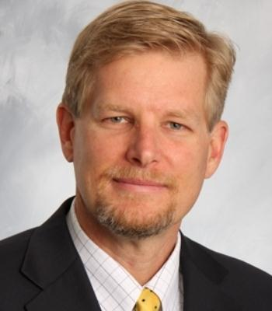 | Mark Danowski, Agent  Allstate Insurance Company  369 Main Street  Center Moriches, NY, 11934  (631) 874-3827 Office  (631) 874-3880 Fax | 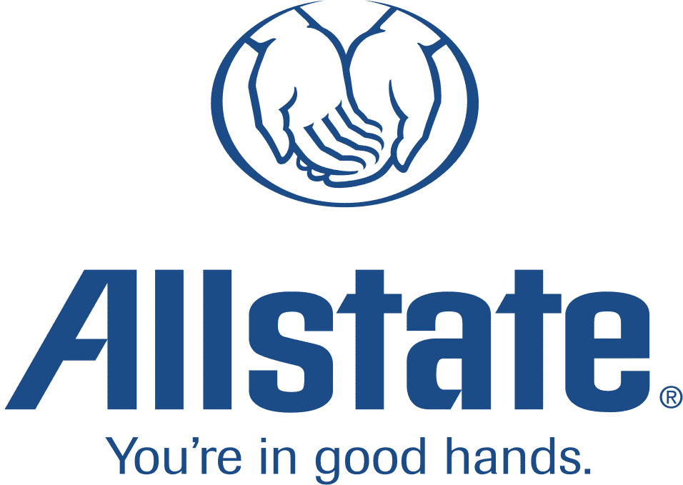

April 30, 2015
Hon. Andrew M. Cuomo
New York State Governor
Executive Chamber
State Capitol, 2nd Floor
Albany, New York 12224

Re: Support for Liberty/Port Ambrose
Dear Honorable Governor Cuomo:
Businesses suffered large increases in the price of natural gas the past two years because of the extremely cold winter weather.
Since increased supply drives prices down, there is little doubt that the Port Ambrose project will help enhance natural gas capacity here on Long Island as well as stabilize and reduce the cost of energy.
The state needs new energy sources and the Port Ambrose proposal looks like it will give us the help we need.
Please support Liberty Natural Gas, LLC’s proposed Port Ambrose project.
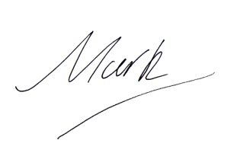
Sincerely,

MARK DANOWSKI
Agent/Manager
Allstate Insurance Company

