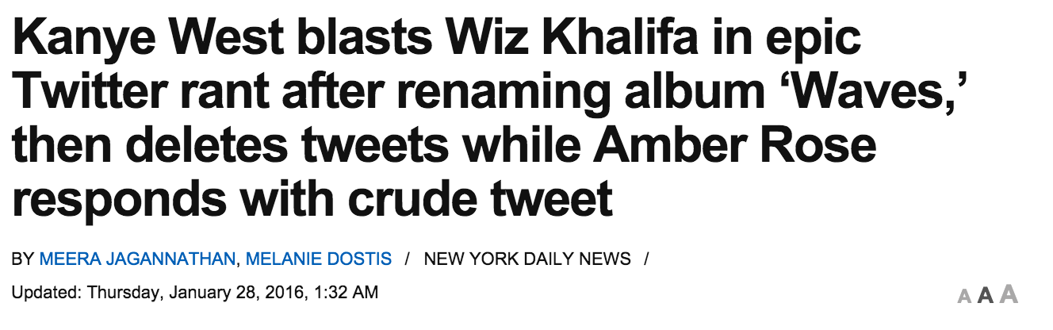
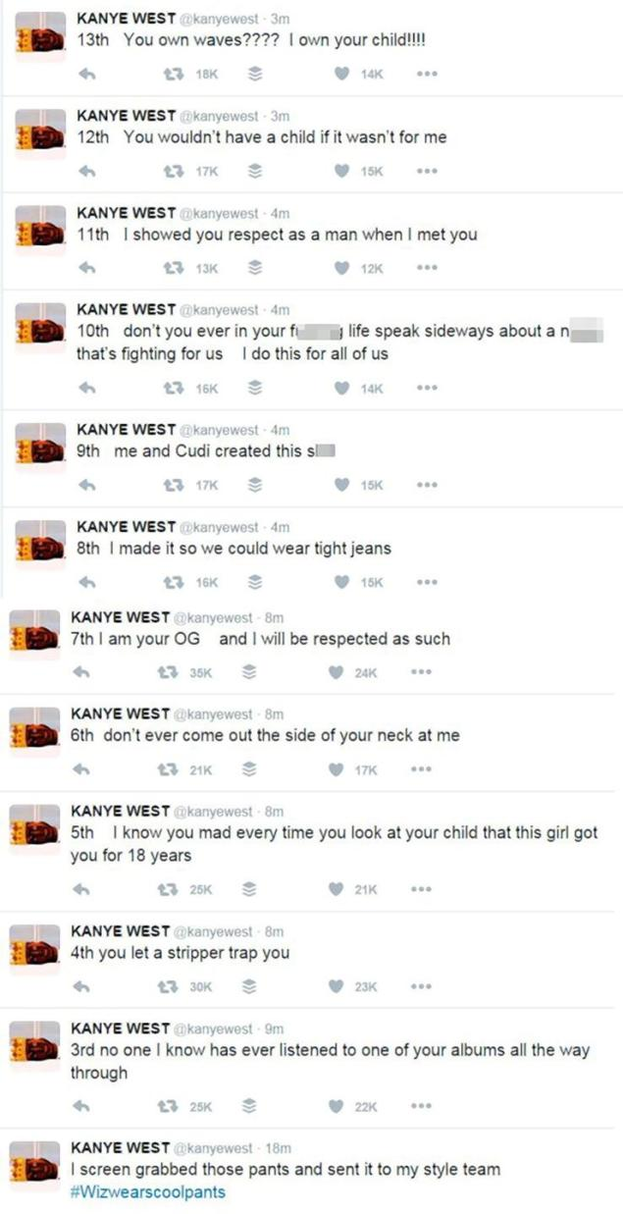
KANYE WEST
Jordan Richmond
PR-103
Sec. 21268
January 31, 2016

CONTROLLED
UNCONTROLLED

