The NFL

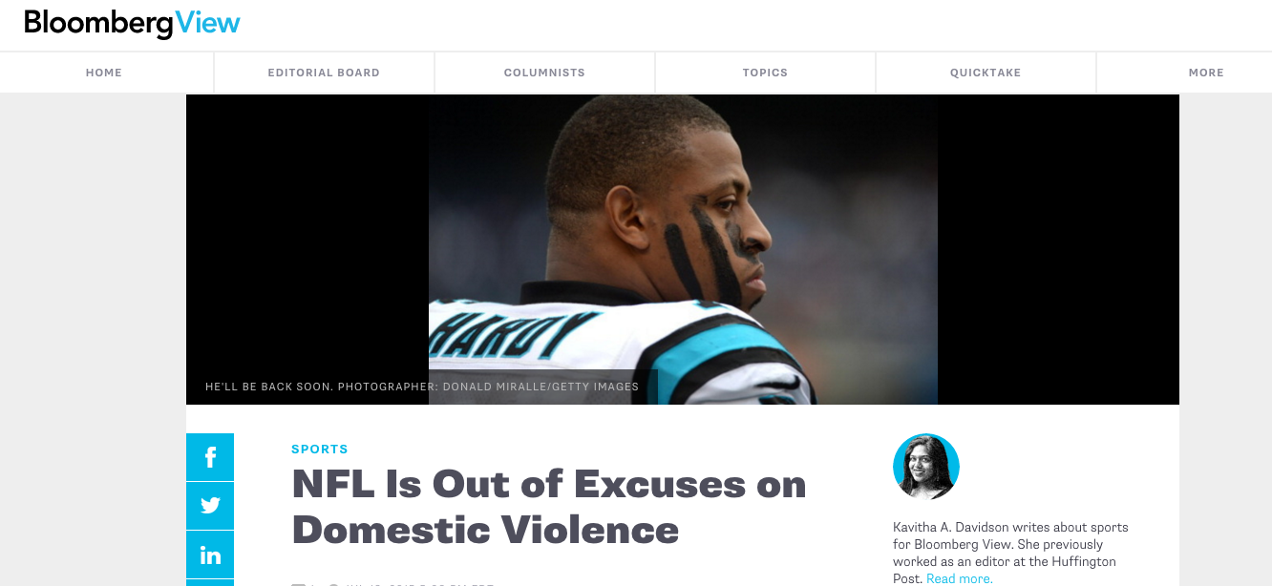
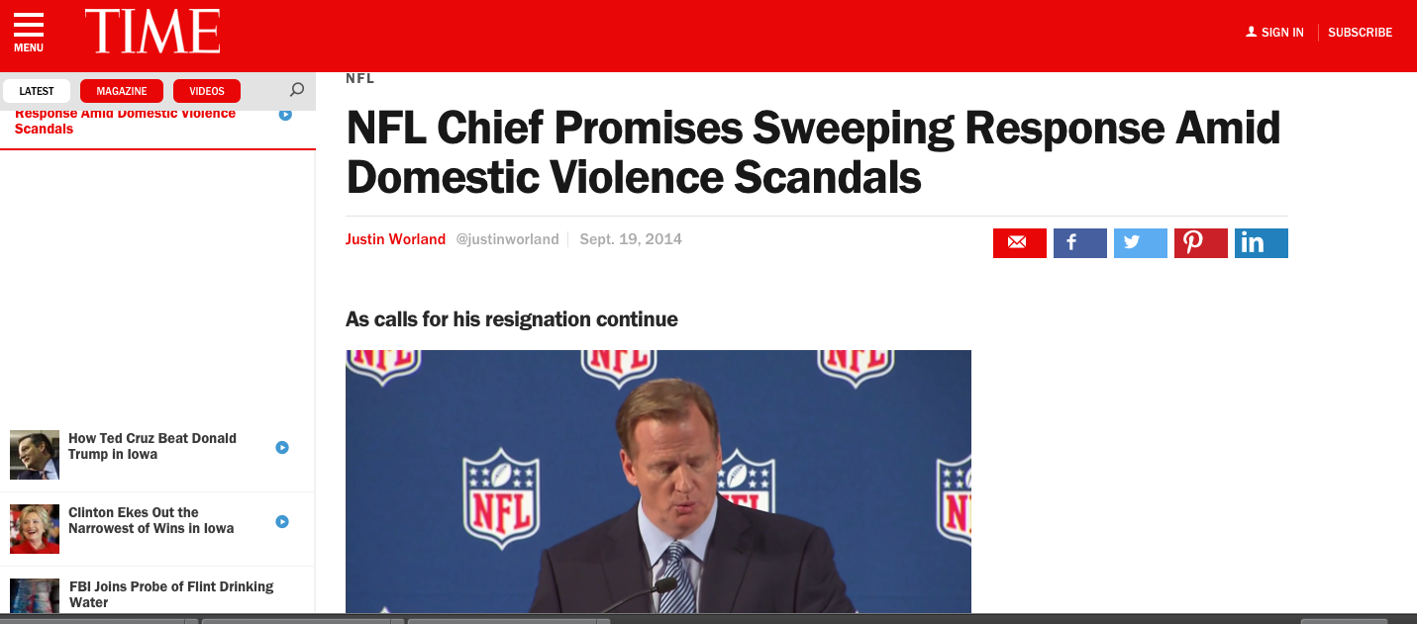

Controlled Uncontrolled

Tyler Sakry, PR103

