Grease Live

Controlled Uncontrolled

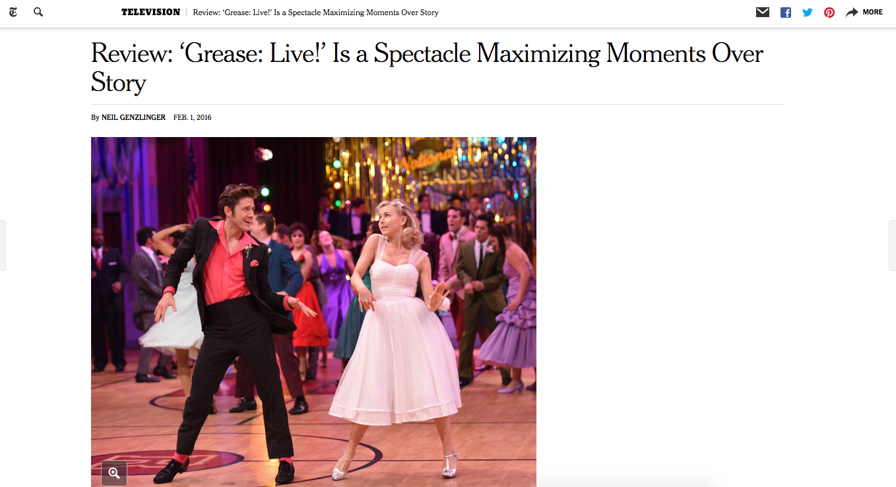

Grace Finlayson, PR-103, Sec. 21268, February 2, 2016

