Volkswagen

Uncontrolled
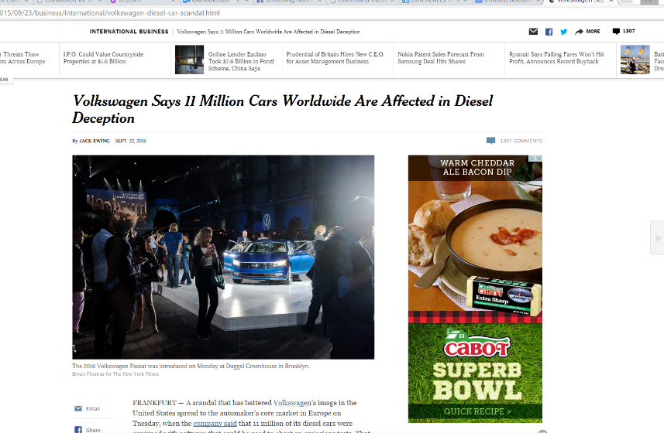

Controlled
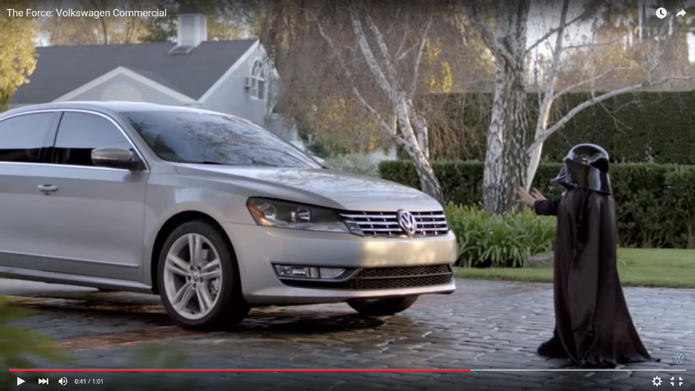

Kylie Todd; PR 103; Sec 21268; Feb 1, 2016

