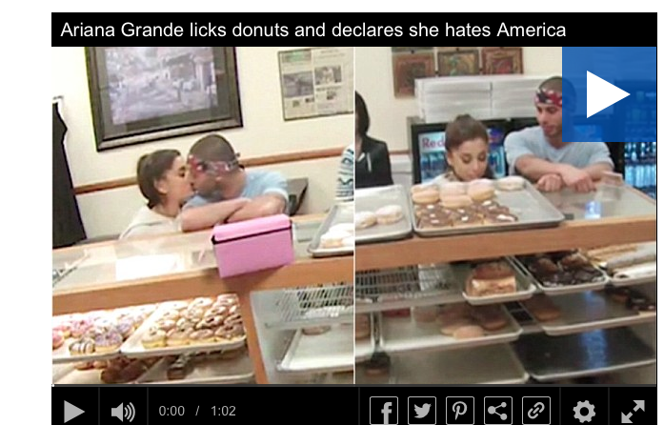
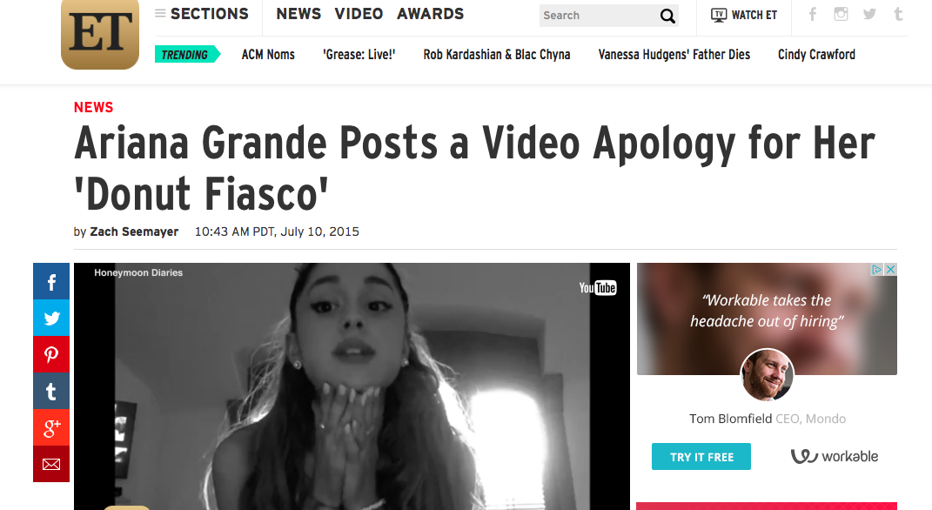
Danielle Ferrara, PR-103, Sec 21268, January 31,2016

Ariana Grande
Uncontrolled
Controlled

