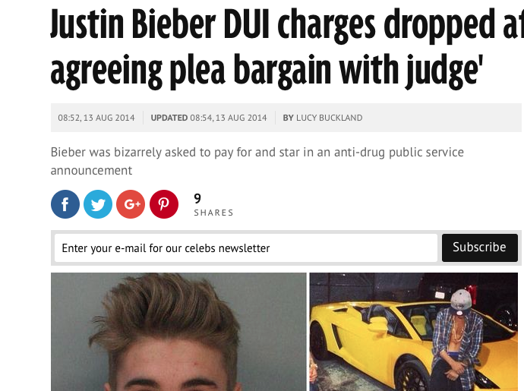
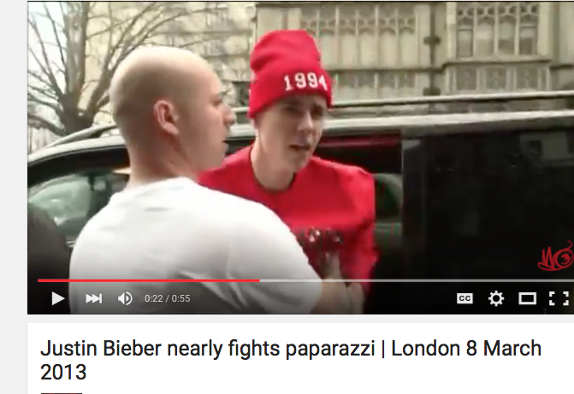
Regina Ferrara, PR-103, Sec 21268, January 31,2016
Justin Bieber
Uncontrolled
Controlled

